**Worksheet 1: Risk-based Decision 3-04**

**Group 1**

To estimate risk, 2 components must be considered:

1)The probability of occurrence of harm (frequency, likelihood)

2) The severity of that harm (consequences)

**Facts serve as the basis for estimating risk.**

Based on the facts presented below ,

* the likelihood of losing a specimen in transit is

(check one) Low_______ Medium_______ High ______

* the consequences from losing a referred specimen are

**(check one)** Low_______ Medium_______ High ______

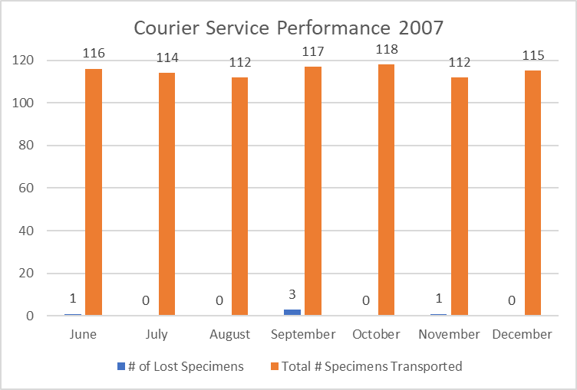

Propose the appropriate action to take for the laboratory?

How will you ensure the proposed action, once implemented, is effective?

**Handout 2: Risk-based Decision**

**Group 2**

To estimate risk, 2 components must be considered:

1)The probability of occurrence of harm (frequency, likelihood)

2) The severity of that harm (consequences)

**Facts serve as the basis for estimating risk.**

Based on the facts presented below ,

* the likelihood of losing a specimen in transit is

(check one) Low_______ Medium_______ High ______

* the consequences from losing a referred specimen are

**(check one)** Low_______ Medium_______ High ______

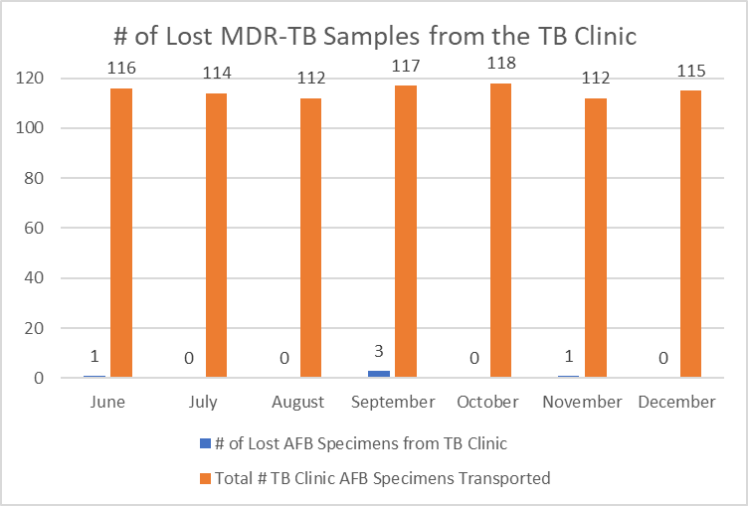

Multi-drug-resistant tuberculosis (MDR-TB)

Propose the appropriate action to take for the laboratory?

How will you ensure the proposed action, once implemented, is effective?

**Handout 2: Risk-based Decision**

**Group 3**

To estimate risk, 2 components must be considered:

1)The probability of occurrence of harm (frequency, likelihood)

2) The severity of that harm (consequences)

**Facts serve as the basis for estimating risk.**

Based on the facts presented below ,

* the likelihood of losing a specimen in transit is

(check one) Low_______ Medium_______ High ______

* the consequences from losing a referred specimen are

**(check one)** Low_______ Medium_______ High ______

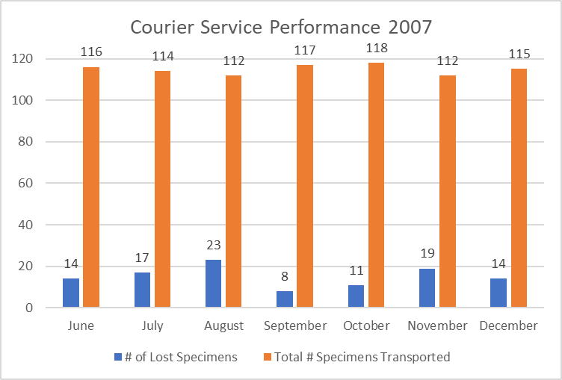

Propose the appropriate action to take for the laboratory?

How will you ensure the proposed action, once implemented, is effective?

**Handout 2: Risk-based Decision**

**Group 4**

To estimate risk, 2 components must be considered:

1)The probability of occurrence of harm (frequency, likelihood)

2) The severity of that harm (consequences)

**Facts serve as the basis for estimating risk.**

Based on the facts presented below ,

* the likelihood of losing a specimen in transit is

(check one) Low_______ Medium_______ High ______

* the consequences from losing a referred specimen are

**(check one)** Low_______ Medium_______ High ______

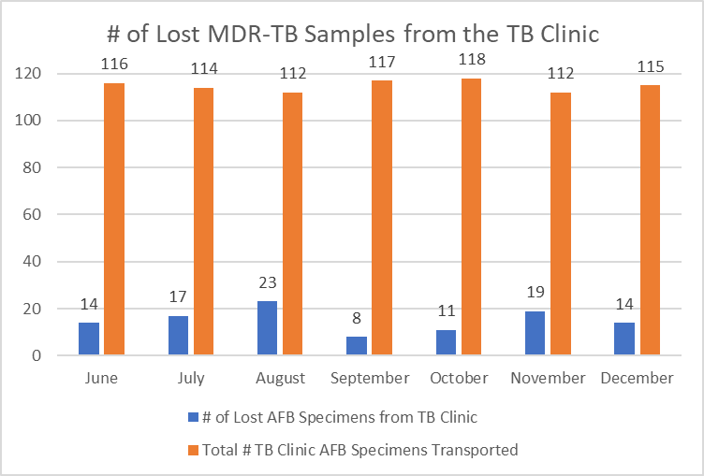

Multi-drug-resistant tuberculosis (MDR-TB)

Propose the appropriate action to take for the laboratory?

How will you ensure the proposed action, once implemented, is effective?